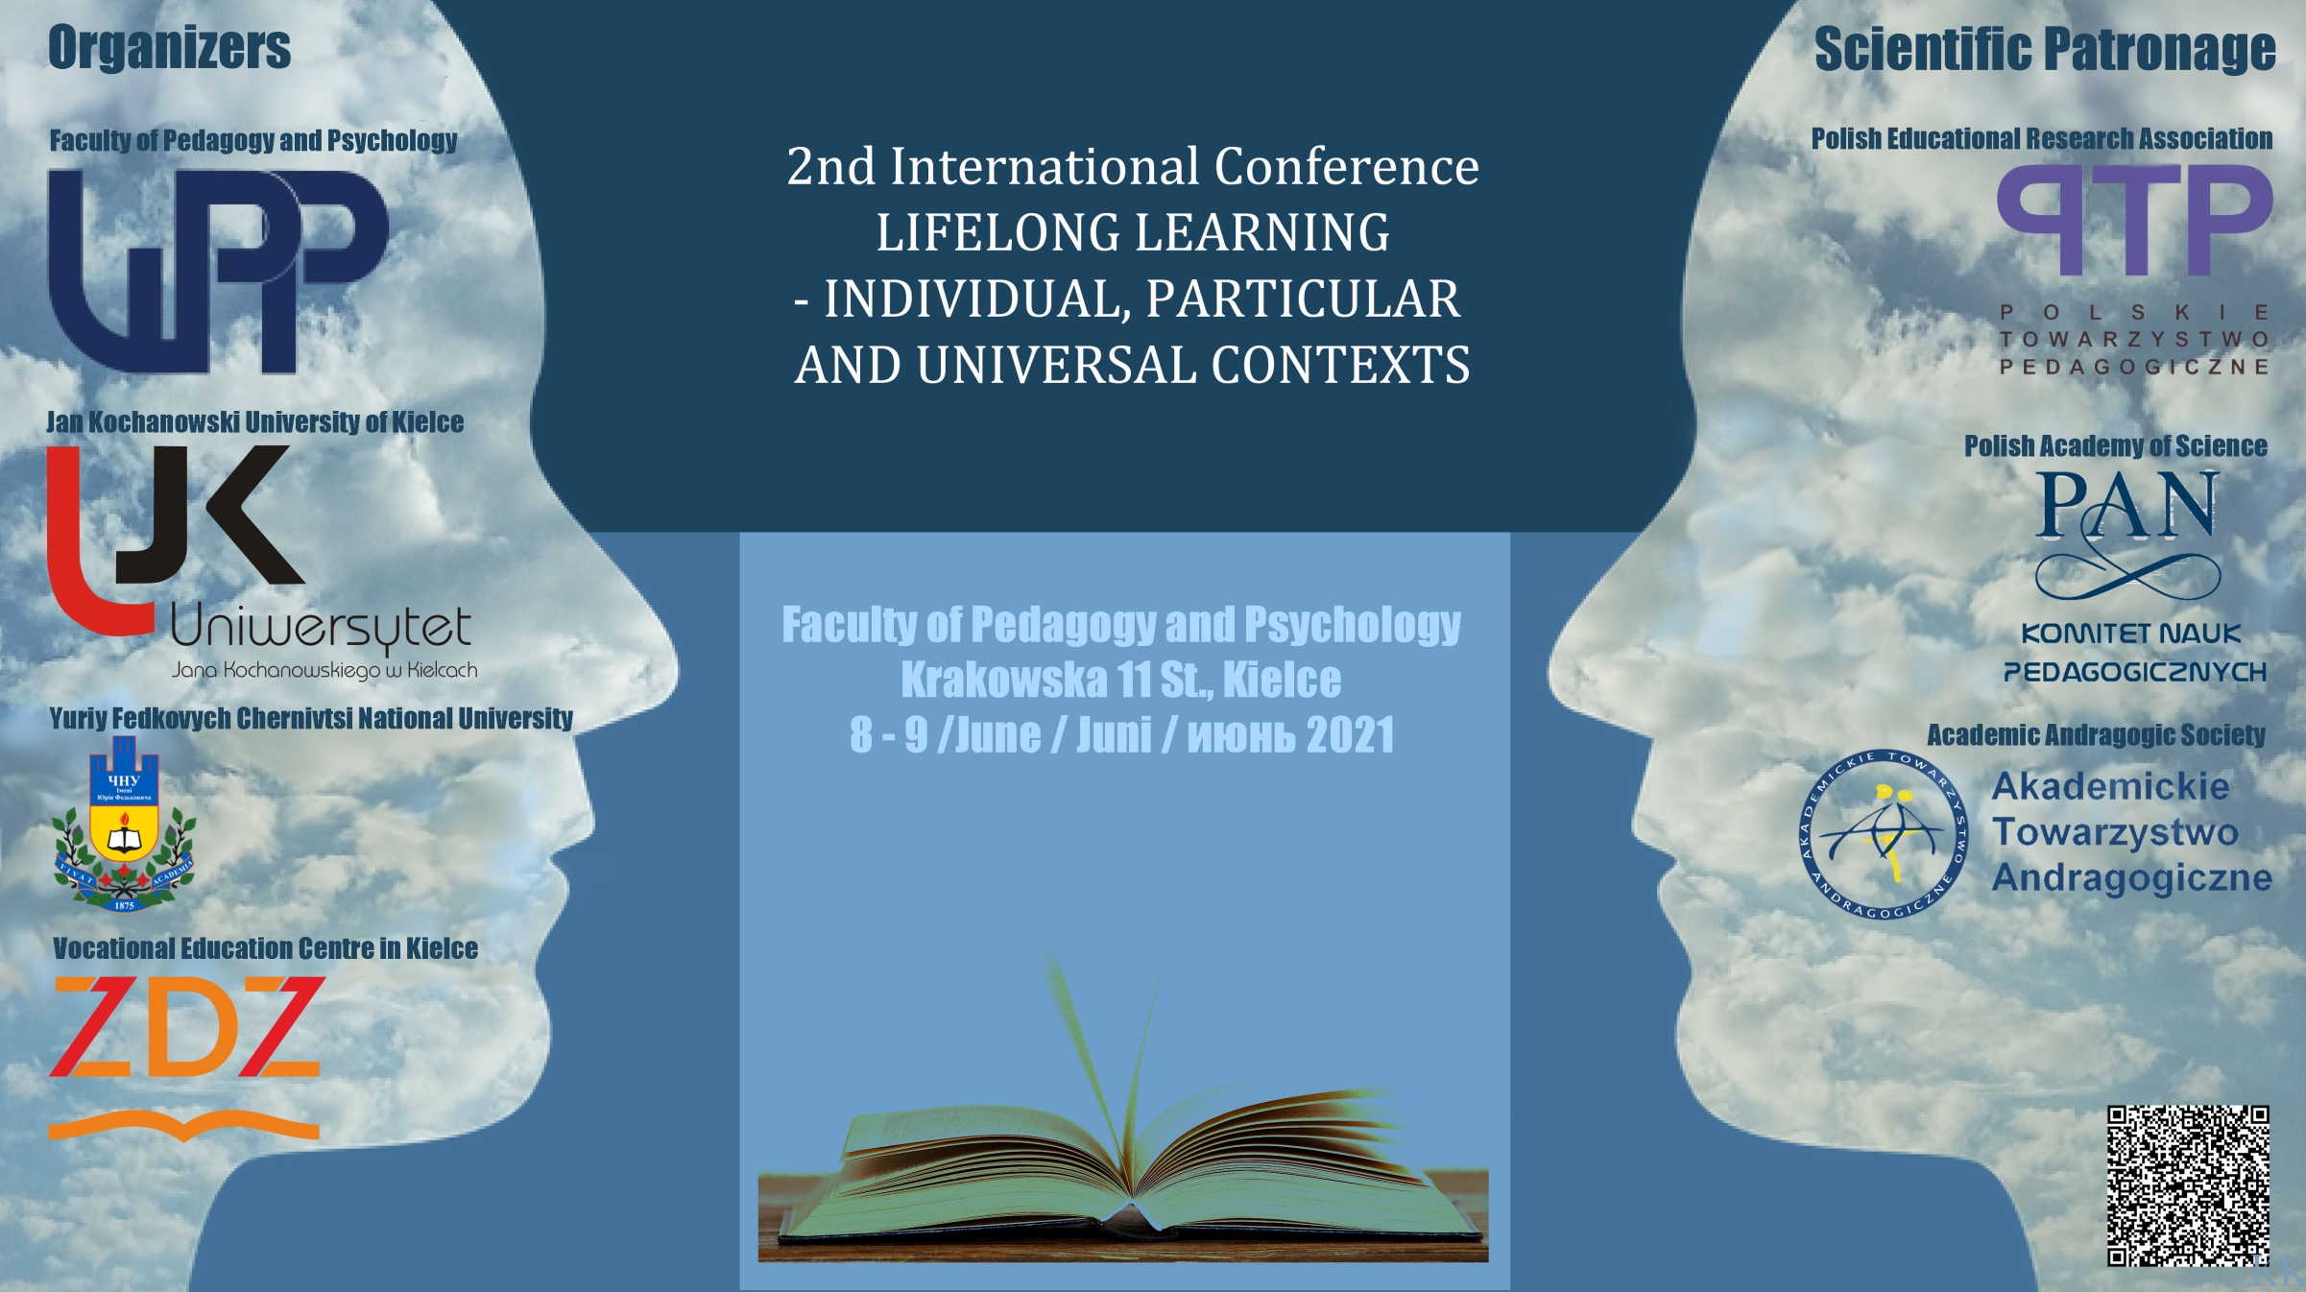

**The Scientific Committee:**

**The Chair of the Scientific Committee:**

**Dr hab. Agata Chabior, prof. UJK – Jan Kochanowski University in Kielce**

**The Co-chairs of the Scientific Committee:**

**Dr hab. Małgorzata Stawiak-Ososińska, prof. UJK – Jan Kochanowski University in Kielce**

**Dr hab. Agnieszka Szplit, prof. UJK – Jan Kochanowski University in Kielce**

Prof. dr hab. Tadeusz Aleksander – Wszechnica Polska Szkoła Wyższa   
w Warszawie

Prof. dr hab. Andrzej Bogaj – Staropolska Szkoła Wyższa w Kielcach

Prof. Folko Cimagalli – University LUMSA Rzym (Włochy)

Prof. Otylia Clipa – University Stefan cel Mare Suceava (Rumunia)

Prof. dr hab. Agnieszka Cybal-Michalska – Uniwersytet Adama Mickiewicza   
w Poznaniu

Prof. Otylia Dandara – State University of Moldova w Kiszyniowie (Mołdawia)

Prof. dr hab. Wanda Dróżka – Uniwersytet Jana Kochanowskiego w Kielcach

Prof. dr hab. Elżbieta Dubas – Uniwersytet Łódzki

Prof. dr hab. Stefan Michał Kwiatkowski – Akademia Pedagogiki Specjalnej im. Marii Grzegorzewskiej w Warszawie

Prof. Nataliya Machynska – Ivan Franco National University of Lviv (Ukraina)

Prof. dr hab. Joanna Madalińska-Michalak – Uniwersytet Warszawski

Prof. dr hab. Bożena Matyjas – Uniwersytet Jana Kochanowskiego w Kielcach

Prof. Marisa Musaio – Catholic University of the Sacred Heart Mediolan (Włochy)

Prof. dr hab. Marian Nowak – Katolicki Uniwersytet Lubelski, Lublin

# Prof. Mariya Olijnyk – Yuriy Fedkovych Chernivtsi National University (Ukraina)

Prof. Davide Parmigiani, President of Association for Teacher Education in Europe (ATEE), University of Genova (Włochy)

Prof. dr hab. Małgorzata Przeniosło – Uniwersytet Jana Kochanowskiego   
w Kielcach

Prof. dr hab. Eleonora Sapia-Drewniak – Uniwersytet Opolski

Prof. Sofia Silva – the Polytechnic Institute of Coimbra Coimbra (Portugalia)

Prof. dr hab. Jolanta Szempruch – Uniwersytet Rzeszowski

Prof. dr hab. Władysława Szulakiewicz – Uniwersytet Mikołaja Kopernika   
w Toruniu

Prof. dr hab. Elżbieta Trafiałek – Uniwersytet Jana Kochanowskiego w Kielcach

Prof. dr hab. Adam Zych – Dolnośląska Szkoła Wyższa we Wrocławiu

Dr hab. Henryk Bednarczyk prof. ITeE – Instytut Technologii Eksploatacji   
w Radomiu

Dr hab. Beata Bugajska prof. USz. – Uniwersytet Szczeciński

Dr hab. Sławomir Chrost, prof UJK – Uniwersytet Jana Kochanowskiego   
w Kielcach

Dr hab. Jerzy Halicki prof. UwB – Uniwersytet w Białymstoku

Dr hab. Małgorzata Halicka prof. UwB – Uniwersytet w Białymstoku

Dr hab. Piotr Kostyło prof. UKW – Uniwersytet Kazimierza Wielkiego   
w Bydgoszczy

Dr hab. Barbara Skałbania prof. UJK – Uniwersytet Jana Kochanowskiego   
w Kielcach

Dr hab. Hanna Solarczyk-Szwec prof. UMK – Uniwersytet Mikołaja Kopernika   
w Toruniu

Dr hab. Agnieszka Stopińska-Pająk - Akademia WSB

Dr hab. Zofia Szarota prof. UW – Uniwersytet Warszawski

Dr hab. Mariola Wojciechowska prof. UJK – Uniwersytet Jana Kochanowskiego   
w Kielcach

Dr hab. Artur Fabiś – Uniwersytet Pedagogiczny im. KEN w Krakowie

Dr hab. Tomasz Maliszewski – Akademia Marynarki Wojennej w Gdyni

**The Organising Committee:**

**dr Renata Miszczuk – The Chair of the Organising Committee**

**dr Małgorzata Krawczyk-Blicharska – The Co-chair**

**dr Justyna Miko-Giedyk - secretary**

**dr Anna Przygoda – secretary**

**dr Katarzyna Potaczała-Perz - secretary**

**dr Małgorzata Bogaj – committee member**

**dr Agata Jopkiewicz – committee member**

**dr Barbara Klasińska – committee member**

**mgr Krzysztof Kupczewski – media support**

**Conference Call**

The conference "**Lifelong learning - individual, particular and universal contexts**" is a reaction to the ongoing social transformations, limitations and opportunities resulting from the ubiquitous globalization, technological progress and epidemic conditions that affect the everyday life and education. Along with the observed changes, more and more often some questions arise about universal educational values, about the importance of educational traditions of a country or region, for national minorities or immigrants, but also about the individual people’s needs. Therefore, it seems extremely important to undertake a scientific discussion, on the one hand about unification and striving for universality, and on the other - about the opposite of universalism, e.g. particularism and individualism in education. In this new situation for all of us, it is also necessary to reflect on remote, lifelong learning in conditions of various limitations.

Universal values, the implementation of which is postulated by all countries worldwide, are maintaining peace and taking care of the natural environment, developing the culture of dialogue and tolerance, shaping pro-ecological attitudes, cultivating the values of humanism, respecting human rights as well as counteracting nationalism, racism and totalitarianism. It is also important to acknowledge patriotic education, regionalism, religious or cultural diversity, independent education, and individual educational needs. The three concepts mentioned in the title of the conference that seem different in their meaning - universalism, particularism and individualism - are not mutually exclusive, but complement and enrich each other, provided their reasonable understanding, interpretation and implementation.

The conference aims at exchanging the knowledge and experience of scientists from various European countries and discussing the readiness of a person for lifelong learning, taking into account individual, local, regional, national and universal contexts.

**Scientific Patronage**

Polish Educational Research Association Polish Academy of Science Academic Andragogic Society

  

**Institutional Patronage**

Rector of The Jan Kochanowski University in Kielce - prof. dr hab. Stanisław Głuszek

Voivode of the Świętokrzyskie Voivodeship - Zbigniew Koniusz

Marshal of the Świętokrzyskie Voivodeship - Andrzej Bętkowski

Mayor of Kielce - Bogdan Wenta

**Media Patronage**

“Humanitas University's Research Papers - Pedagogy” (Zeszyty Naukowe Wyższej Szkoły Humanitas. Pedagogika)



**Business Partners**

RESTART Foundation

Special Economic Zone "Starachowice"

Perfopol Starachowice

During the conference, we would like to focus on the themes of great significance or value to every human being, regardless of age, sex, origin, and nationality.

We hope to interest and inspire all the participants to exchange views and discuss the following:

**1. Continuity of education - civilization, social, cultural and historical dimensions.**

**2. Educational, cultural and social challenges of the present day.**

**3. Universalism of human work - work as a determinant of human existence.**

**4. Child, family, senior - upbringing and dialogue.**

**5. Global environment - local environment, social relations and social groups.**

**6. Education for all age groups.**

**7. School, teacher, learner - individual and particular contexts.**

**8. New educational reality – distance education.**

**Registration and publication:**

* For registration use the on-line form: <https://forms.gle/4FuJCzF3W8TFevUh7>
* The registration will close on 30th April 2021.
* The presented papers will be published in the journals: "Journal of Continuing Eduction” and “Humanitas University's Research Papers- Pedagogy” - after receiving positive reviews AND in the form of a peer-reviewed collective work (publication in a publishing house from the ministerial list). The papers should be prepared in accordance with the requirements of the editors of the journals.
* Two forms of participation are provided: on-site and on-line participation. Please, indicate your choice in the registration form. Links for on-line participation are provided below.
* The conference fee is PLN 300 and includes: participation, publication, lunches and catering excluding the formal dinner on 8th June (to be additionally paid - PLN 120). Online participation without publication is offered for free.
* Accommodation is NOT provided by the Organising Committee. The list of recommended hotels will be provided later.
* In case of cancelling the participation, the organizers will not refund the conference fee.
* Travel costs for conference participants are covered by the delegating units.
* Conference fee must be paid till 10th May 2021, to the account:

**FUNDACJA RESTART**

**Milczany 123, 27-600 Sandomierz**

**71 1050 1416 1000 0090 3157 9676**

**Use: NAME & SURNAME -„EDUKACJA”**

**All the questions concerning the conference should be sent to:** edukacjaustawicznaujk@gmail.com

**The conference programme will be sent after 15th May.**

Here is the meeting link in the Zoom app/

8 June 2021

Join Zoom Meeting <https://zoom.us/j/92392490431?pwd=NU9iSEdCNnNWVHpObjdmc05PeE5JZz09>

Meeting ID: 923 9249 0431

Passcode: 747215

9 June 2021

Join Zoom Meeting <https://zoom.us/j/99755188015?pwd=TEsyUVVGaEJkUFNjZDVXYzhBSUtYUT09>

Meeting ID: 997 5518 8015

Passcode: 747215

**Both links will be also sent to the e-mail address provided in the registration form three days before the conference**.

**Thank you for your registration. See you at the conference.**

***The Organising Committee***