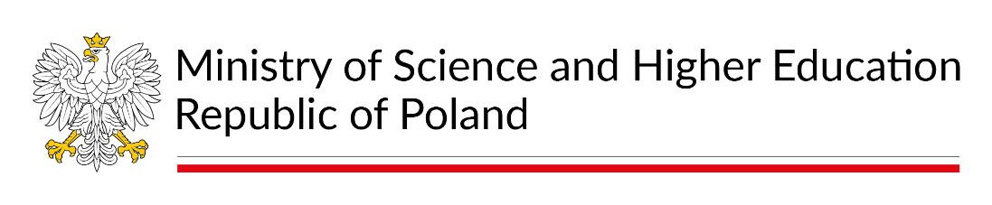
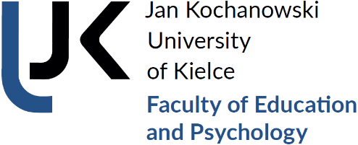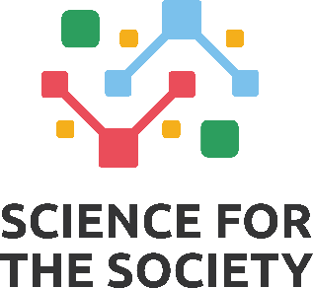

The project is co-financed from the state budget under the "Science for Society II" programme of the Minister of Education and Science (Project No. NdS-II/SP/0429/2023/01).
Registration Form for Participants
for the
International Scientific and Training Conference
"YOUNG PEOPLE IN THE CHANGING WORLD: AN INTERDISCIPLINARY PERSPECTIVE"
Kielce, 27–28 October 2026

Name, surname
Title/academic degree
Affiliation/Institution
Correspondence address
Phone number
e-mail address
MEALS
Traditional |  | Other dietary preferences
Dinner 27 October | yes |  | no
Dinner 28 October | yes |  | no
Attendance at the Gala Dinner on 27 October | yes |  | no
MODE OF PARTICIPATION
Paper presentation/ Scientific poster
TITLE OF THE PAPER/SCIENTIFIC POSTER
In Polish language
In English language
Names of co-authors and their affiliations
Presentation language
Technical equipment required for the presentation
Abstract of the presentation in Polish and English (200–250 words)
Keywords in Polish and English

Please indicate
Please underline

